**Task5.1**

**What are the main differences between Awake() and Start()? What can/should be done in the method Awake()?**

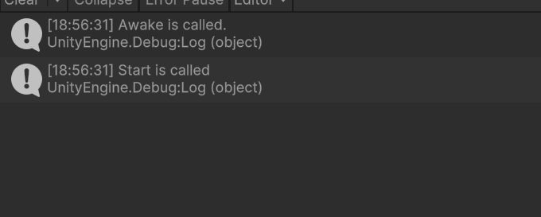

In Unity development, there are main differences between `Awake()` and `Start()` methods. Here are the differences and the tasks that can/should be done in the `Awake()` method:

1. Invocation Order: The `Awake()` method is called immediately after a game object is instantiated, whereas the `Start()` method is called after the `Awake()` method and before the first `Update()` method.

2. Script Activation: The `Awake()` method is called when the script is activated, regardless of whether the game object is enabled or not. On the other hand, the `Start()` method is called when the script is activated and the game object is enabled.

3. Frequency of Invocation: The `Awake()` method is called only once when the game object is instantiated, while the `Start()` method is called every time the game object is enabled.

In the `Awake()` method, you can perform initialization tasks such as setting initial variables, finding references, and preparing the game object's state. It is commonly used to initialize properties in the script but should not rely on the state of other game objects or call methods on other game objects since their `Awake()` methods may not have been called yet.

In the `Start()` method, you can perform tasks that need to be done at the start of the game, such as starting coroutines, playing sound effects, initializing game logic, etc. In the `Start()` method, you can safely use references to other game objects and call their methods.

To summarize, the `Awake()` method is used for initialization tasks and focuses more on the initialization of the script itself. On the other hand, the `Start()` method is used to perform tasks at the start of the game and may depend on the states of other game objects.

**Task5.2**

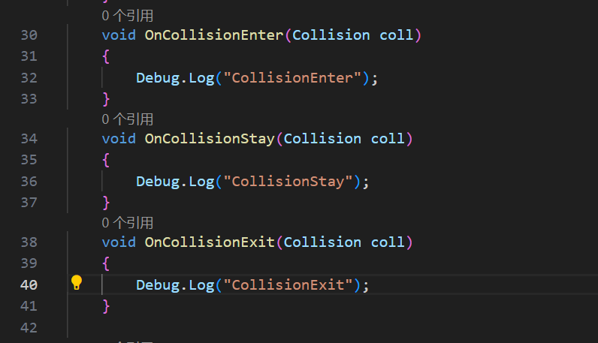

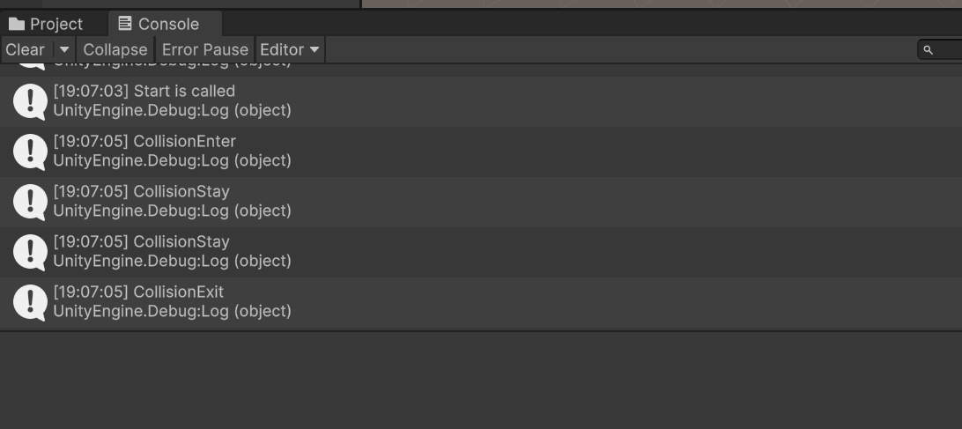

**Task5.3**

**In the Unity editor, tick the box ‘Is Trigger’ in the Inspector for the ‘Cube’. ‘Play’ the game, what happens then?**

The three method OnTriggerEnter( ), OnTriggerStay( ) and OnTriggerExit( ) are called.

And the cube passed through the sphere.

